# Configure shared storage using azure file service

1.

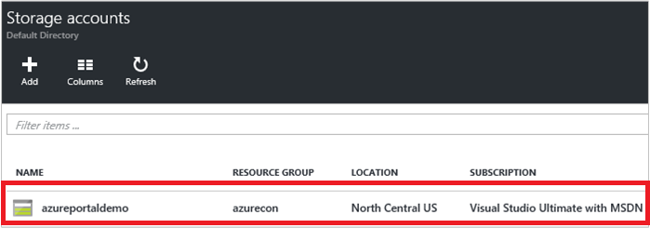

2.

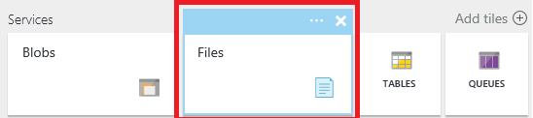

3.

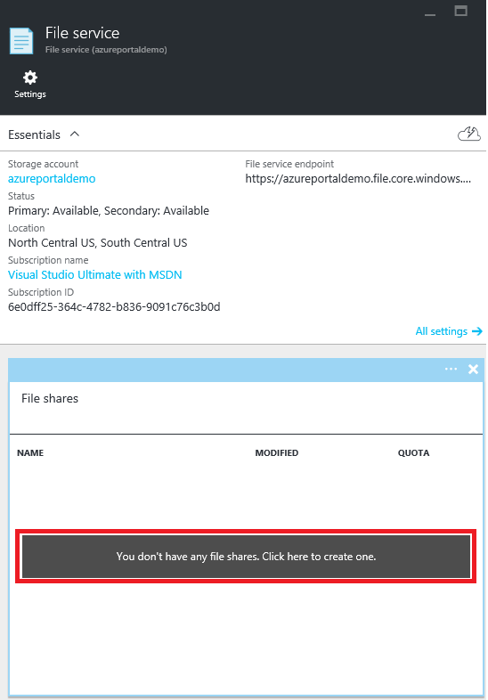

4.

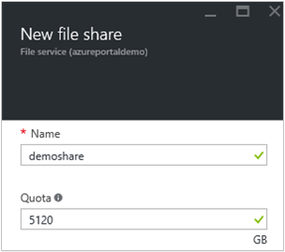

5.

### Upload and download files

Choose one file share your already created.

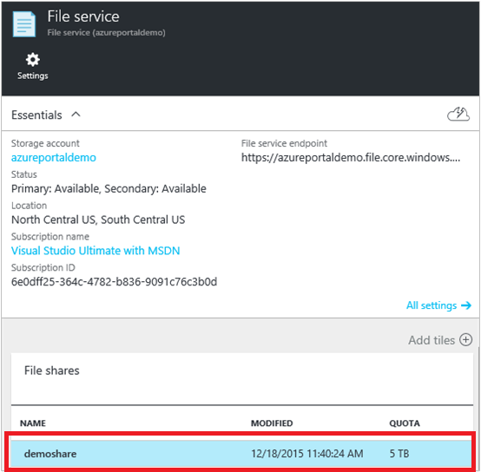

Click **Upload** to open the user interface for files uploading.

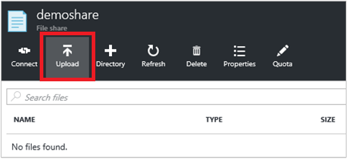

Right click on one file and choose **Download** to download it into local.

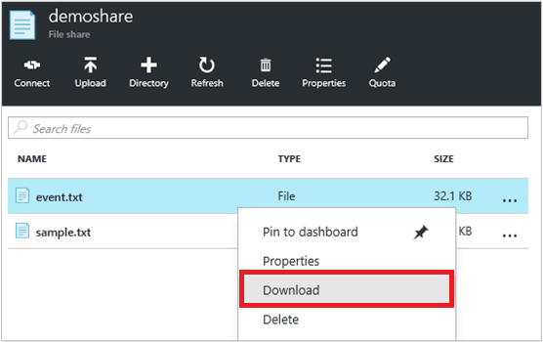

### Manage file share

Click **Quota** to change the size of the file share (up to 5120 GB).

